

FACULTY OF TECHNOLOGY AND ENGINEERING
DEVANG PATEL INSTITUTE OF ADVANCE TECHNOLOGY AND RESEARCH
DEPARTMENT OF INFORMATION TECHNOLOGY

A.Y. 2026-27 [SEMESTER 3]

LAB MANUAL

CEUE203: Object Oriented Programming


Practical 8

Exception handling and resource management
Problem Statement:
1. Guarded calculator: handle invalid numbers and division by zero, retry, and record each attempt in finally.
2. Warehouse issue: use checked stock and quantity exceptions while continuing through all requests.
3. AutoCloseable resource: demonstrate closure after failure while retaining the original exception.
Expected Output: The sample programs demonstrate the required behavior; see the captured console output below.

Solution:

GuardedCalculator.java
import java.util.Scanner;
public class GuardedCalculator {
private static final class DivideByZeroException extends Exception {
private static final long serialVersionUID = 1L;
DivideByZeroException() { super("Cannot divide by zero."); }
}
private static double calculate(double left, double right, String operator)
throws DivideByZeroException {
return switch (operator) {
case "+" -> left + right;
case "-" -> left - right;
case "*" -> left * right;
case "/" -> {
if (right == 0) throw new DivideByZeroException();
yield left / right;
}
default -> throw new IllegalArgumentException("Operator must be +, -, *, or /.");
};
}
public static void main(String[] args) {
try (Scanner scanner = new Scanner(System.in)) {
while (true) {
System.out.print("Enter calculation (number operator number): ");
try {
double left = Double.parseDouble(scanner.next());
String operator = scanner.next();
double right = Double.parseDouble(scanner.next());
System.out.println("Result: " + calculate(left, right, operator));
break;
} catch (NumberFormatException exception) {
System.out.println("Invalid number. Try again.");
scanner.nextLine();
} catch (DivideByZeroException | IllegalArgumentException exception) {
System.out.println(exception.getMessage());
scanner.nextLine();
} finally {
System.out.println("Calculation attempt recorded.");
}
}
}
}
}

ResourceDemo.java
public class ResourceDemo {
private static final class SampleResource implements AutoCloseable {
private boolean closed;
void use() {
if (closed) throw new IllegalStateException("Resource is already closed.");
System.out.println("Resource is open.");
}
@Override
public void close() {
closed = true;
System.out.println("Resource closed.");
}
}
public static void main(String[] args) {
try (SampleResource resource = new SampleResource()) {
resource.use();
throw new IllegalStateException("Original failure");
} catch (IllegalStateException exception) {
System.out.println("Reported: " + exception.getMessage());
}
}
}

WarehouseDemo.java
import java.util.Map;
public class WarehouseDemo {
private static final class OutOfStockException extends Exception {
private static final long serialVersionUID = 1L;
private final int shortfall;
OutOfStockException(int shortfall) {
super("Out of stock by " + shortfall);
this.shortfall = shortfall;
}
int shortfall() { return shortfall; }
}
private static final class InvalidQuantityException extends Exception {
private static final long serialVersionUID = 1L;
InvalidQuantityException() { super("Quantity must be positive."); }
}
private static final class Warehouse {
private final Map<String, Integer> stock = new java.util.HashMap<>(
Map.of("Pen", 3, "Book", 1));
void issue(String item, int quantity)
throws OutOfStockException, InvalidQuantityException {
if (quantity <= 0) throw new InvalidQuantityException();
int available = stock.getOrDefault(item, 0);
if (quantity > available) throw new OutOfStockException(quantity - available);
stock.put(item, available - quantity);
System.out.println("Issued " + quantity + " " + item);
}
}
public static void main(String[] args) {
Warehouse warehouse = new Warehouse();
String[][] requests = {{"Pen", "2"}, {"Book", "3"}, {"Pen", "0"}, {"Pencil", "1"}};
for (String[] request : requests) {
try {
warehouse.issue(request[0], Integer.parseInt(request[1]));
} catch (OutOfStockException exception) {
System.out.println(exception.getMessage() + " (shortfall "
+ exception.shortfall() + ")");
} catch (InvalidQuantityException exception) {
System.out.println(exception.getMessage());
}
}
}
}

MiniBank Project Work:

MiniBank progress ? Practical 8
Completed: checked BankException subclasses carry explicit banking failures; deposit, withdraw, and transfer validate amounts and report insufficient funds instead of silently returning failure.
Single project location: Java Programs\Minibank

Progressive source excerpts:

Minibank/src/main/java/minibank/exception/BankException.java
package minibank.exception;
public class BankException extends Exception {
private static final long serialVersionUID = 1L;
public BankException(String message) { super(message); }
}

Minibank/src/main/java/minibank/exception/InsufficientFundsException.java
package minibank.exception;
public final class InsufficientFundsException extends BankException {
private static final long serialVersionUID = 1L;
private final long shortfall;
public InsufficientFundsException(long shortfall) {
super("Insufficient funds; short by " + shortfall + ".");
this.shortfall = shortfall;
}
public long getShortfall() { return shortfall; }
}

Minibank/src/main/java/minibank/exception/InvalidAmountException.java
package minibank.exception;
public final class InvalidAmountException extends BankException {
private static final long serialVersionUID = 1L;
public InvalidAmountException(String message) { super(message); }
}

Minibank/src/main/java/minibank/exception/AccountNotFoundException.java
package minibank.exception;
public final class AccountNotFoundException extends BankException {
private static final long serialVersionUID = 1L;
public AccountNotFoundException(String accountNumber) {
super("Account not found: " + accountNumber);
}
}

Minibank/src/main/java/minibank/model/Account.java ? checked withdrawal
public synchronized boolean withdraw(long amount)
throws InsufficientFundsException, InvalidAmountException {
if (amount <= 0) throw new InvalidAmountException("Withdrawal must be positive.");
if (!canWithdraw(amount)) {
throw new InsufficientFundsException(Math.max(0, amount - balance));
}
balance = Math.subtractExact(balance, amount);
return true;
}

Minibank/src/main/java/minibank/service/BankService.java ? transfer
public void transfer(String fromNumber, String toNumber, long amount)
throws BankException, IOException {
Account from = find(fromNumber);
Account to = find(toNumber);
if (from.equals(to)) throw new IllegalArgumentException("Transfer accounts must differ.");
Account first = Comparator.comparing(Account::getAccountNumber).compare(from, to) < 0
? from : to;
Account second = first == from ? to : from;
synchronized (first) {
synchronized (second) {
from.withdraw(amount);
try {
to.deposit(amount);
} catch (InvalidAmountException | ArithmeticException exception) {
from.deposit(amount);
throw exception;
}
}
}
TransactionLog.append(logFile, "WITHDRAW " + amount);
TransactionLog.append(logFile, "DEPOSIT " + amount);
}

Output Screenshot:
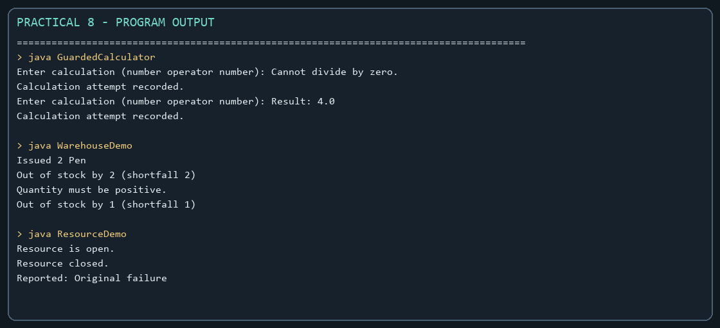
Captured from the compiled practical programs.

